A000-ME-Iran-Amlash-Ram Rhyton- Ceramic- 9th – 8th c BCE

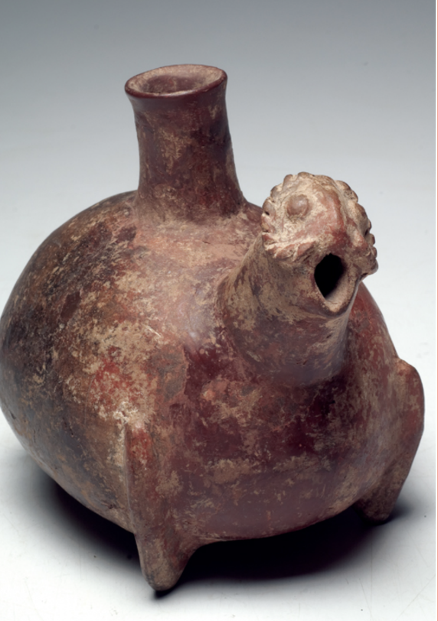 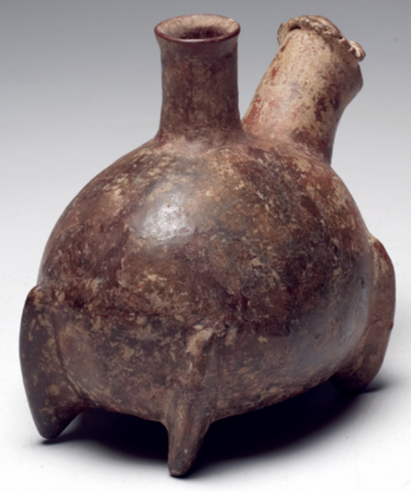

**Case No.: 2**

**Accession No.**

**Formal Label:** Iran-Amlash-Ram Rhyton- Ceramic- 9th – 8th c BCE

**Display Description:**

Large, ovoid zoomorphic rhyton of red-brown burnished ware from the 9th – 8th c BCE. The corpulent rhyton stands on four stump legs with a central, long-necked spout on its back and an applied, highly stylized head of a ram with curled spiral horns and an open mouth.

**LC Classification:**

**Date or Time Horizon:** 9th – 8th c BCE

**Geographical Area:** Iran-Amlash

**Map:**

**GPS coordinates:**

**Cultural Affiliation:**

**Media:**

**Dimensions:**

**Weight:**

**Condition:**

**Provenance:**

**Discussion:**

**References:**

|  |  |
| --- | --- |
| Culture or Country: | Iran. |
| Period: | 1st millennium BCE |
| Size: | 7-3/4”H. x 8-3/4”L. |
|  |  |
| Description: | Scattered encrustation on the surface attests to its ancient age. It was repaired from original pieces with restoration over the break-lines. |
| Provenance: | Private NYC collection, acquired prior to 1970, to present owner by inheritance. Ex Arte Primitivo. It comes with certificate of authenticity form Arte Primitivo. |

The term “Amlash” or “Amlash culture” began to be used with Paris exhibition of 1961.

The term “Amlash” (Amlaš), since 1959, derives from excavations of archeological artifacts dated to the 9th-8th centuries BCE in the Alborz range valley in the vicinity of Amlash village in SE Gīlān, Iran. The term was popularized by a 1961 Parisian exhibition. Burnished red-brown ceramic animal effigy vases like this one appear to form a continuous tradition within these finds, however, the term “culture” as applied to these finds at this time is premature and awaits further archaeological definition.

The earliest discovery of Amlash objects was made in the Kalār Dašt area of Māzandarān where bronze, gold, and pottery objects were found in 1934 (H. Samadi, “Les découvertes fortuites de Kalar Dasht, Garmabak, Emam et Tomadjan (Mazanderan et Gilan),” Arts Asiatiques 6, 1959, pp. 175ff.). Further finds were made near the villages of Tomaǰān, Emām, and Garmābak in 1954 (ibid.). Excavations of objects from rock-lined tombs have been carried out at Mārlīk (E. O. Negahban, A Preliminary Report on Marlik Excavation, Tehran, 1964), Kalūraz (A. Hakemi, “Kaluraz and the Civilization of the Mardes,” Archaeologia Viva 1, 1968, pp. 63-65), and several sites in Daylamān (N. Egami et al., Dailaman I-IV, Tokyo, Institute of Oriental Culture, University of Tokyo, 1965-71).

*Bibliography:*

A. Parrot, “Acquisitions et inédits du Musée du Louvre, 13. Animaux et ceramiques d’Amlash,” Syria 40, 1963, pp. 236-41.

R. Ghirshman, The Arts of Ancient Iran, New York, 1967, pp. 31-38.

R. Biscione, Ceramica di Amlash, Museo Nazionale d’Arte Orientale, Schede 6, Rome, 1974.

Razmārā, Farhang II, p. 24.

Sh. Ahkami, “Interview with Ezatollah Negahban,” *Persian Heritage* 29, Spring 2003, pp. 57-59 (in Persian).

E. Akurgal, *Urartäische und Altiranische Kunztzentren*, Ankara, 1968.

P. Amiet, “Autour de Marlik,” in *Archaeologia Iranica et Orientalis: Miscellaenea in honorem Louis Vanden Berghe,* ed. L. De Meyer and E. Haerinck, Ghent, 1989, pp. 311-22.

Idem. “Mārlik et Chogha Zanbil,” *Revue d’Assyriologie et d’archéologie orientale* 84/1, 1990, pp. 44-47.

P. Calmeyer, “Mesopotamien und Iran im II. und I. Jahrtausend,” in *Mesopotamien und seine Nachburn,* ed. H.-J. Nissen and J. Regner, Berlin, 1982, pp. 339-48.

Idem, “Middle Babylonia Art and Contemporary Iran,” in *Later Mesopotamia and Iran: Tribes and Empires 1600-539 BC*, ed. J. Curtis, London, 1995, pp. 33-45.

I. M. Diakonoff, “Media,” in *Camb. Hist. Iran* II: *The Median and Achaemenian Periods*, ed. I. Gershevitch, Cambridge, 1985, pp. 36-148.

A. Hakemi, “Kaluraz and the Civilization of the Mardes,” *Archaeologia Viva* 1, 1968, pp. 63-65.

Ernie Haerinck, “The Iron Age in Guilan: proposal for a Chronology,” in *Bronze-working Centres of Western Asia, c. 1000-539 B.C.*, ed. J. Curtis, London, 1998, pp. 63-78.

S. Jones, *The Archaeology of Ethnicity: Constructing Identities in the Past and Present*, London, 1997.

S. O. Kāmbaḵš-Fard, “An Account of the Archaeological Investigations in the Eastern Foothills of Gilan, Northern Iran,” *Iranian Journal of Archaeology and History* 17, 1995, pp. 16-33 (in Persian).

G. N. Kurochkin, “Archaeological Search for the Near Eastern Aryans and the Royal Cemetery of Mārlik in Northern Iran,” in *South Asian Archaeology 1993*, ed. A. Parpola and P. Koskikallio, vol. 1, Helsinki, 1994, pp. 389-95.

U. Löw, “Kunsthandel und Fälschungsproblematik,” *Mitteilungen des Deutschen Archäologen-Verbandes* 24/1, 1993, pp. 36-44.

Idem. “Der Freidhof von Mārlik—Ein Datierungsvorschlag (I),” *AMI* 28, 1995/1996, pp. 119-61.

Idem, *Figürlich verzierte Metallgefässe aus Nord und Nordwestiran*, Münster, 1998.

M. Malekzāda, “Andia: A Petty Kingdom in Grand Media and Metalworks of Marlik,” *Iranian Journal of Archaeology and History* 16, 1994, pp. 12-18 (in Persian).

M. Moghadam, “Dailaman: An Archaeological Survey,” in *A Survey of Persian Art*, vol. 17: *From Prehistoric Times to the End of the Sasanian Empire*, ed. A. Daneshvari and J. Gluck, Costa Mesa, Calif., 2005, pp. 103-8.

O. W. Muscarella, “Fibula and Chronology, Mārlik and Assur,” *Journal of Field Archaeology* 11/4, 1984, pp. 413-19.

Idem, *The Lie Became Great: The Forgery of Ancient Near Eastern Cultures*, Groningen, 2000a.

Idem, Review of Löw, 1998 in *Bibliotheca Orientalis* 57/1-2, January-April 2000b, pp. 188-96.

ʿE.-A. Negahbān, “The Wonderful Gold Treasure of Marlik,” *Illustrated London News*, *28* April 1962, pp. 663-64.

Idem, “The Wonderful Gold Treasures of Marlik,” *Bulletin of the Society of the Ancient Iranian Culture* 1, 1342 Š./1963, pp. 21-28.

Idem, “A Brief Report on the Excavations at Mārlik Tepe and Pileh Qaleh,” *Iran* 2, 1964a, pp. 13-19.

Idem, *A Preliminary Report on Mārlik Excavations, Gohar Rud Expedition, Rudbar, 1961-1962*, Tehran, 1343 Š./1964b (in Persian).

Idem, “Notes on Some Objects from Marlik,” *JNES* 24, 1965, pp. 309-27.

Idem, “Vestiges d’une civilisation inconnue,” *Le Courrier de l’UNESCO*, June 1966, pp. 16-21.

Idem, “Marlik: A Royal Necropolis of the Second Millennium,” *Archaeologia Viva* 1, 1968, pp. 59-62.

Idem, “Pottery Figurines of Marlik,” in *Memorial Volume of the Vth International Congress of Iranian Art and Archaeology, Tehran, Isfahan, Shiraz, 11th-18th April 1968*, Tehran, 1972, vol. 1, pp. 142-52.

Idem, “The Gold Vase with the Story of Life: Mārlik Royal Cemetery,” *Journal of the Faculty of Letters and Human Sciences, University of Tehran* 23/1-2, 1355 Š./1976, pp. 42-67 (in Persian).

Idem, “The Seals of Marlik Tepe,” *JNES* 36, 1977, pp. 81-102.

Idem, “Pottery and Bronze Human Figurines of Marlik,” *AMI* 12, 1979, pp. 157-73.

Idem, “Maceheads from Marlik,” *AJA* 85, 1981, pp. 367-78.

Idem, *Metal Vessels from Marlik,* Munich, 1983.

Idem, *Metal Vessels from Mārlik*, Tehran, 1368 Š./1987 (in Persian).

Idem, “Mosaic, Glass, and Frit Vessels from Marlik,” in *Essays in Ancient Civilization Presented to Helene J. Kantor*, ed. A. Leonard and B. Williams, Chicago, 1989a, pp. 221-27.

Idem, “Pendants from Marlik,” *IA* 24, 1989b, pp. 175-208.

Idem, “Horse and Mule Figurines from Marlik,” in *Archaeologia Iranica et Orientalis: Miscellaenea in honorem Louis Vanden Berghe,* ed. L. De Meyer and E. Haerinck, Ghent, 1989c, pp. 287-309.

Idem, “Silver Vessels of Mārlik with Gold Spout and Impressed Gold Designs,” in *Iranica Varia: Papers in Honor of Professor Ehsan Yarshater*, ed. D. Amin, M. Kasheff, and A. Sh. Shahbazi, Leiden, 1990, pp. 144-51.

Idem, *Weapons from Marlik*, Berlin, 1995.

Idem, *Marlik: The Complete Excavation Report*, 2 vols., Philadelphia, 1996a.

Idem, *Excavations at Marlik*, Tehran, 1375 Š./1996b (in Persian).

Idem, *Fifty Years of Iranian Archaeology*, Tehran, 1376 Š./1997 (in Persian).

Idem, “Suggestions on the Origin and Background of the Mārlik Culture,” *IA* 33, 1998, pp. 43-56.

Idem, “Excavations at Mārlik Tepe,” *EIr* X/6, 2001, pp. 627-34.

E. Porada, *The Art of Ancient Iran: Pre-Islamic Cultures*, New York, 1965.

Ḥ.-A. Ṣamadi, *Les découvertes fortuites Kalardasht, Garmabak, Emam et Tomadjan (Mazandaran et Guilan)*, Tehran, 1959.

ʿA.-A. Vaḥdati, *Research on the Ceremonial Aspects of Images, Figures, Motifs, and Figurines from Marlik*, M.A. Diss., Department of Archaeology, Tehran University, 2005a (in Persian).

Idem. “Another Look at the Gold Vessel with the So-called “Story of Life” from Marlik,” *Bāstānšenāsi* 1, 2005b, pp. 39-51 (in Persian).

Idem, “An Assessment of the Dates Proposed for the Mārlik Cemetery,” *Bāstānšenāsi* 2, 2006, pp. 55-64 (in Persian).

Ch. K. Wilkinson, “Art of Marlik Culture,” *The Metropolitan Museum of Art Bulletin* 24, 1965, pp. 101-9.

(Kamyar Abdi)

Last Updated: March 15, 2010

Culture: Parthisch

Period: 2nd-1st century B.C.

Material: Terrakotta

Dimensions: 20.5 cm x 29 cm

Price: 2 800 Euro

Ref: 6105

Provenance: Antikenhandel Yeganeh from 1950 to 1983. Thence collection of the heirs. Sold on 11 August 2015 to Galerie Antiken-Kabinett Gackstätter, inventory number 01497. With certificate of Galerie Antiken-Kabinett and a letter of the Yeganeh heirs confirming the provenance.

Condition: Two fragments on the outlet reattached, otherwise wonderfully preserved.

Description: Large libation vessel of the red polished ware from the Parthian period. The corpulent, ovoid rhyton stands on four stump legs. In the front a long, slender neck, forming to the end a pouring spout which finishes off horizontally in the form of a snout. Two plastically set off eyes with circular pupils. In between a knob indicating a small horn. On the spine a funnel-shaped outlet and in the back a loop handle, reaching from the outlet to the body. See: Wilfried Seipel, “1.000 Jahre persische Kunst”, Kunsthalle Bonn 2002, Abb. 145.